Bayesian Queueing Simulation for Dynamic Port Logistics: Predictive Modelling of Truck Flow and Congestion Risk

**Izza Hasanul Muna1**

1 Corporate Transformation and Program Management Group, Pelindo Head Office

*E-mail: izza.muna@intermaths.eu

**Abstract.** Efficient port logistics require robust strategies to manage some complex and uncertain constraints, including truck arrivals, limited service capacity, and evolving operational conditions. This paper presents a Bayesian queueing simulation framework that integrates probabilistic modelling and discrete-event simulation to evaluate truck congestion and service delays in container ports. We model the system as an M/M/c queue, where truck arrivals are treated as a Poisson process and service times are exponentially distributed across c parallel resources. By simulating 24-hour trucking activity and applying Bayesian updating for real-time arrival rate estimation, the framework adaptively identifies peak congestion periods and operational stress points. Performance metrics, including average waiting time, queue length, dock utilization rate and probability of congestion are assessed across four operational scenarios, including baseline flow, increased load, dock expansion, and scheduled downtime. The findings indicate that congestion is more sensitive to service capacity disruptions than to arrival rate fluctuations. The integration of stochastic modelling with adaptive response mechanisms enables more resilient and data-driven decision-making for port authorities. This simulation framework can be used to support strategic planning efforts by revealing critical temporal and operational bottlenecks, enabling ports to adjust dynamically to changing demand conditions and infrastructure constraints.

**Keywords:** Queueing theory, Bayesian simulation, port logistics, truck congestion, congestion management

1. Introduction

Major global container ports operate in increasingly complex environment[1], as trade volumes grow and vessels increase after covid-19 outbreaks. In this case, efficiency and adaptability are crucial to maintain the steady flow of collection and distribution goods. Ports in countries such as Indonesia, China, and USA rely heavily on drayage trucks for these activities [2]. As a result, the management of truck flow has become a critical determinant of port performance and overall logistics efficiency.

However, port operations often face challenges such as uncertain truck arrivals, limited dock capacity, and fluctuating service conditions that can lead to congestion and delays. These inefficiencies not only disrupt operational performance but also incur significant economic and environmental costs. For example, congestion at Tanjung Priok Port in 2025, was reported to cause losses of approximately IDR 120 billion due to delayed cargo handling and extended truck turnaround times [3]. Similarly, in the United States, congestion at the Ports of Los Angeles and Long Beach in 2021 led to over 100 vessels idling offshore with average delays of 23 days, contributing to an estimated $90 billion in disrupted trade across sectors [4],[5]. The environmental implications are also substantial. Prolonged truck idling during congestion events has been linked to increased emissions, with studies reporting that port-related trucking activities contributed to 23% of CO₂ emissions in affected port zones [6].

To address these operational challenges, many ports have adopted static scheduling systems to manage truck arrivals and dock assignments. While these systems provide a structured approach to planning, they often lack the flexibility to adapt to real-time fluctuations in traffic volume, service disruptions, or unexpected events such as equipment breakdowns or weather delays. A key limitation stems from their inability to account for the stochastic nature of truck arrivals and service durations. Unlike vessel schedules, which are typically planned in advance, truck arrivals are influenced by a multitude of unpredictable external factors, including urban traffic congestion, driver availability, supplier delivery windows, and last-minute logistics decisions. As a result, they may fail to respond effectively during peak and critical periods. Zhang et al. found that traditional/ static scheduling models can exhibit prediction errors exceeding 30% during peak disruptions, significantly compromising reliability and leading to operational bottlenecks [7].

Based on this illustration, ports require a more agile and responsive operational framework that can continuously assess system conditions, leverage real-time data, and dynamically optimize resource allocation using probabilistic forecasts. Actually, technological advances in real-time monitoring, IoT-enabled vehicles, and port automation have made it possible to collect granular data on truck movement and service activities. However, converting this data into actionable insights requires advanced modelling techniques that can handle uncertainty, variability, and adaptive decision-making. This is where probabilistic and Bayesian frameworks offer some advantages. Unlike deterministic approaches, Bayesian methods allow continuous updating of system beliefs based on observed data [8], making it possible to predict congestion risk and adapt resource allocation in real time. Another advantage of a Bayesian approach is that uncertainty from all parameter estimates is accounted for in reported summaries, which is particularly important when data is sparse or noisy [9].

Queueing theory, particularly the M/M/c model, provides a rigorous foundation for simulating port service processes, especially truck flow dynamics across parallel docking channels. By augmenting this framework with a Bayesian inference engine, ports gain real-time visibility into evolving truck arrival patterns, enabling dynamic estimation of latent parameters (e.g., arrival rate fluctuations) and proactive identification of emerging bottlenecks in truck queues. This integration supports data-driven interventions such as dynamic rescheduling of docking slots to reduce truck idle time, staggered gate appointments to mitigate peak hour congestion, and on-demand capacity adjustments.

This research introduces a Bayesian queueing simulation framework that synthesizes these concepts to support port logistics planning. Through discrete-event simulation of 24-hour trucking activity under various load and resource conditions, the model captures both routine and extreme operational scenarios. Key performance indicators such as average waiting time, queue length, dock utilization rate and probability of congestion are analysed to uncover patterns and inform responsive strategies. This approach introduces an innovative decision-support solution that combines real-time adaptability with predictive analytics to optimize port operations. By focusing explicitly on truck flow dynamics, the framework helps optimize infrastructure use, reduce delays, and guide smarter investments in logistics capacity and resilience.

2. Preliminaries

2.1 Core Queueing Model *– M/M/c system*

The queueing theory constitutes a practical and theoretical tool for stochastic modelling, performance evaluation and control of various concrete systems such as computer systems, logistics and port operations [10][11]. The M/M/c queueing model, a cornerstone of this theory, assumes a memoryless (Markovian) arrival process (M) with *c* parallel servers and exponential service times distributed with rate $μ$ [12]. The number of servers, *c*, corresponds to the number of available docks or cranes in a port terminal, which may vary dynamically depending on operational conditions.

In this research, we adopt the M/M/c queueing model to simulate truck traffic dynamics within a port terminal. Truck arrivals are assumed to follow a Poisson process with arrival rate $λ_{t}$, implying that the interarrival times are independent and exponentially distributed, i.e. $T_{i}\sim Exp\left(λ_{t}^{-1}\right)$. Service time, denoted by $S_{j}\sim Exp\left(μ^{-1}\right)$, are assumed to follow an exponential distribution with mean service rate $μ$. Note that $T_{i}$ is interarrival times between trucks and $S_{j}$ represents service time for truck $j$.

In order to capture the operational dynamics of the M/M/c queueing model, we define each key performance metric individually, along with its respective formula and underlying assumptions. The traffic intensity or utilization of the system is a critical parameter given by:

$$ρ=\frac{λ}{cμ},ρ<1$$

To determine the likelihood of congestion and quantify delays, the following formula is utilized [13]. The probability that all servers are busy (i.e., a truck must wait) $(P_{wait})$ is given by:

$$P_{wait}=\frac{\frac{{\left(cρ\right)}^{c}}{c!}}{\sum_{k=0}^{c-1}{\frac{{\left(cρ\right)}^{k}}{k!}}+\frac{{\left(cρ\right)}^{c}}{c!\left(1-ρ\right)}}, ρ<1$$

In order to determine the expected waiting time in queue $(W_{q})$, we employ the following established formula, derived from Little's Law and the Erlang-C model [14]:

$$W_{q}=\frac{P_{wait}.μ^{-1}}{c(1-ρ)}$$

These metrics allow for the quantification of service delays and resource utilization in the simulated environment, providing decision support for operational strategies.

2.1 *Bayesian inference for updating truck arrival rate*

Traditional M/M/c queueing models assume a fixed arrival $λ$ rate, but real-world systems often experience variability due to fluctuating demand or external conditions. Bayesian inference offers a principled framework for dynamically updating arrival rate estimates by systematically incorporating new data. This approach enables continuous refinement of beliefs as new evidence emerge [15]. Mathematically, Bayesian inference involves the computation of the posterior probabilities of certain random variables given the prior distribution of other random variables [16]. Specifically, if truck arrivals follow a Poisson distribution with unknown rate $λ_{t}$, the conjugate prior for $λ_{t}$ is a Gamma distribution, denoted as $λ_{t}\sim Gamma(α,β)$ where $α$ is the shape parameter and $β$ is the rate (inverse scale) parameter.

Given $n$ arrivals observed over a time period $t$, the likelihood function based on the Poisson distribution is given below:

$$P\left(n | λ\right)=\frac{{\left(λt\right)}^{n}e^{-λt}}{n!}$$

Since the conjugate prior for $λ_{t}$ is $λ_{t}\sim Gamma(α,β)$, then the probability density function (pdf) of the Gamma distribution is given by:

$$f\left(λ_{t} | α,β\right)=\frac{β^{α}}{Γ(α)}λ^{α-1}e^{-βλ_{t}}$$

where $Γ(α)$ is the gamma function, ensuring normalization. By applying Bayes' theorem, the posterior distribution is proportional to the product of the prior and likelihood, resulting in:

$$P\left(λ_{t} | n,t\right).α.P\left(n | λ_{t}\right).f\left(λ_{t}\right)=λ_{t}^{n}e^{-λ_{t}t}.λ_{t}^{α-1}e^{-βλ_{t}}=λ_{t}^{α+n-1}.e^{-\left(β+t\right)λ_{t}}$$

This is the unnormalized form of a Gamma distribution. Therefore, the posterior is $λ_{t}|n,t\sim Gamma(α+n,β+t)$. This derivation confirms that the posterior remains in the Gamma family, allowing for efficient and analytically tractable updates to the arrival rate estimate. The posterior mean, which serves as the updated estimate of the truck arrival rate, is given by:

$$E\left[λ_{t}\right]=\frac{α+n}{β+t}$$

In this research, the Bayesian approach is used throughout the simulation process to model and adapt to changes in truck arrival rates in real-time. As truck arrival data is collected at each time step, the model updates its belief about the current arrival intensity, effectively learning and responding to emerging congestion patterns. This integration of Bayesian methods ensures that the simulation remains updated with the latest data, facilitating adaptive strategies for port resource allocation and congestion mitigation.

**3. Methods**

This research presents a simulation framework using SimPy to replicate the 24-hour operational behaviour of the port under various conditions. SimPy, which derives its name from 'Simulation in Python,' is a specialized Python package dedicated to creating process-centric discrete-event simulation (DES) models, with all components developed natively in Python [17]. It is a low-level simulation language, which provides easiness in the means of handling the parallel progress of processes in simulation time [18].

The proposed simulation framework characterizes truck arrivals as a Poisson process with intensity parameter $λ$, while service times at each dock follow an exponential distribution governed by the service rate $μ$. The system configuration includes a set number of docks $c$, some of which may become temporarily inoperable due to random failures, simulating mechanical issues or scheduled maintenance. During these failure events, the effective dock capacity is reduced, directly affecting service availability and contributing to potential queuing and congestion. To dynamically infer the truck arrival rate, a Gamma distribution $λ\sim Gamma(α,β)$ is employed as a conjugate prior to the Poisson likelihood. The parameters $α$ and $β$ encode prior beliefs about truck arrival frequency and are updated as hourly truck arrival data is collected. The posterior distribution of the arrival rate is then defined by $λ|n,t\sim Gamma(α+n,β+t)$.

In this study, four experimental scenarios are defined to test different operational conditions by varying the service rate, dock/server capacity, total dock/server failure, dock failure duration, and Bayesian prior parameters $(α,β)$, as summarized in Table 1. These scenarios allow comprehensive evaluation of system behaviour under varying stress levels and information conditions. Performance evaluation relies on key metrics such as average waiting time, queue length, dock utilization rate, and the probability of congestion. For this study, congestion is defined as any instance where the truck queue exceeds 20 vehicles. These metrics are derived from detailed simulation logs that reflect real-time system dynamics and allow for granular analysis of performance under uncertainty.

**Table 1.** Some Scenarios for doing simulation framework

|  |  |  |  |  |  |  |  |
| --- | --- | --- | --- | --- | --- | --- | --- |
| No | Scenario | $$μ$$ | Dock/server Capacity | Total Dock Failure | Time failure/ rest (hour) | $$α$$ | $$β$$ |
| 1 | I | 10 | 3 | 0 | 0 | 15 | 1 |
| 2 | II | 10 | 3 | 0 | 0 | 60 | 2 |
| 3 | III | 10 | 4 | 0 | 0 | 60 | 2 |
| 4 | IV | 10 | 3 | 1 | 2 (4 PM to 6 PM) | 60 | 2 |

To enhance predictive accuracy and responsiveness, the model incorporates Bayesian updating to continuously refine estimates of truck arrival rates. Using a Gamma prior and updating it with observed data, the system adapts over time, improving its ability to anticipate congestion and optimize resource allocation proactively. This integrated methodology serves as a powerful decision-support tool for port authorities, enabling them to effectively manage uncertainty and variability in complex logistics operations while maintaining operational efficiency. The combination of simulation-based performance metrics with adaptive Bayesian learning represents a significant advancement over traditional static analysis approaches, providing both immediate operational insights and long-term strategic value for port management.

**4. Result**

Consider all scenarios in Table 1. Scenario I represents baseline operations with no dock failures ( $μ$ =10 trucks/hour/dock, 3 docks, no failures). By running the simulation, the result for scenario I is given in Figure 1. The results indicate moderately busy port system operating well below congestion thresholds. The key operational metrics indicate an average wait time of 0.06 hours (3 minute 36 seconds), dock utilization at 82.8%, and zero overall congestion probability, demonstrating efficient handling under current conditions. The Bayesian estimation framework applies a Gamma posterior distribution (Gamma posterior $α=547$, $β=24.9$), yielding a mean arrival rate of approximately 21.98 (~22) trucks/hour.

Hourly congestion probabilities remain at zero throughout the day, supported by the queue length data. During 24 hours, the average queue length per hour never approaches the congestion threshold of 20 trucks with the maximum queue length at 8 trucks, confirming the absence of critical bottlenecks. Correspondingly, average waiting times per hour remain low, with occasional short peaks consistent with minor fluctuations in arrival rates and service times. The queue length over time plot further substantiates transient spikes without sustained congestion, indicating the port's capacity adequately matches truck arrival variability.

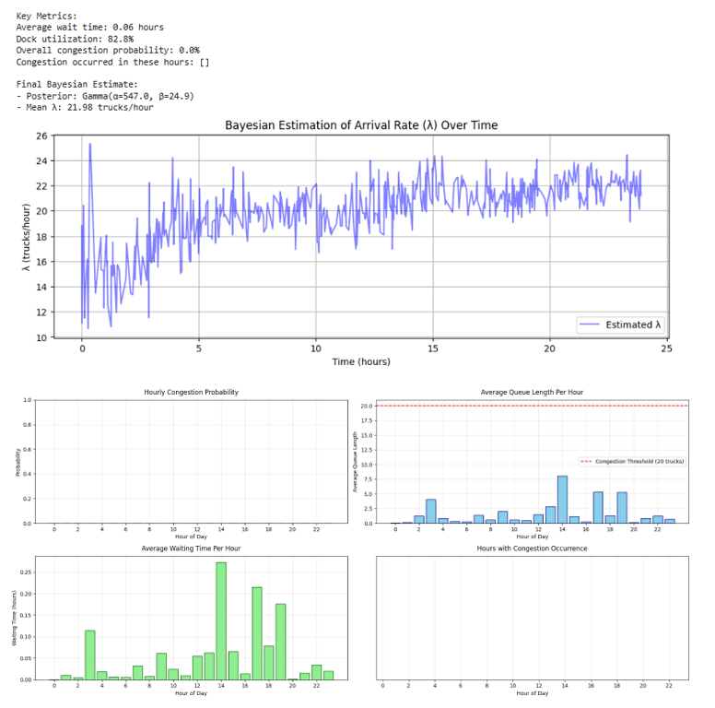

**Figure 1.** Results for scenario I

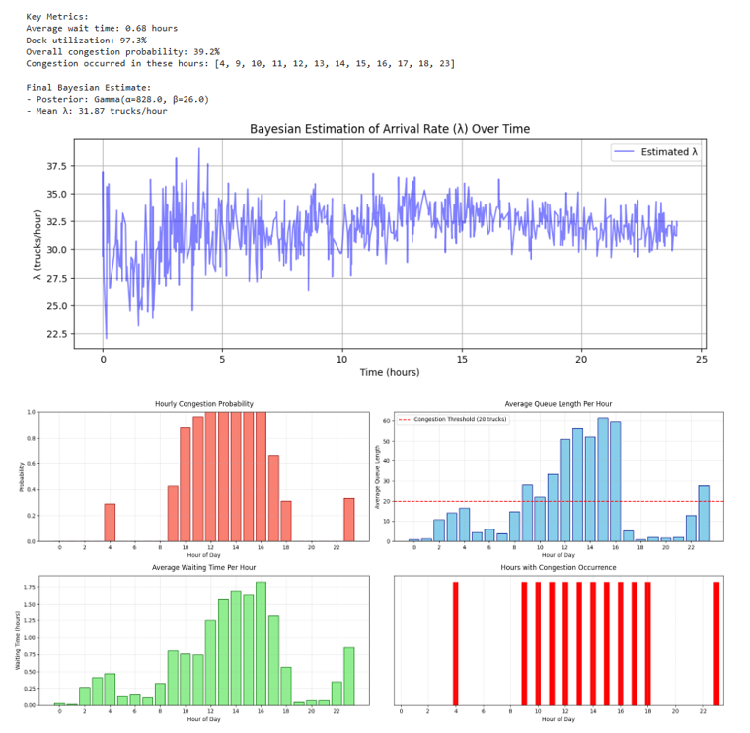

**Figure 2.** Simulation results under scenario II

Now, let us consider Figure 2, which illustrates the system performance for Scenario II, where congestion becomes a persistent challenge. The average wait time for trucks at the dock is approximately 0.68 hours, meaning trucks typically wait around 40 minutes before being serviced. The dock operates at a very high utilization rate of 97.3%, indicating it is almost constantly busy and working near full capacity. Because of this intense usage, overall congestion probability about 39.2%. Specifically, congestion was notably observed at 4 AM, during peak hours from 9 AM to 6 PM and again around 11 PM, likely attributable to elevated truck arrival rates. Furthermore, the probability of congestion during the 12 PM to 4 PM period reaching a value of 1, with the maximum queue length recorded at 60 trucks at 3 PM. By using Bayesian inference, the arrival rate of trucks was estimated with a Gamma distribution characterized by parameters $α=828$ and $β=26$, resulting in an average arrival rate of about 31.87 (~32) trucks/hour. This posterior estimate integrates prior knowledge with observed data, providing a refined and probabilistic understanding of truck arrival patterns, which explains the high utilization and frequent congestion observed at the dock.

To address the congestion in Scenario II, we explore a simple yet impactful adjustment by adding one more dock with the same service rate $μ$. This leads us to Scenario III, where the total number of docks increases from 3 to 4. This adjustment aims to evaluate whether increased server capacity can reduce waiting times, decrease congestion probability, and enhance overall system performance.

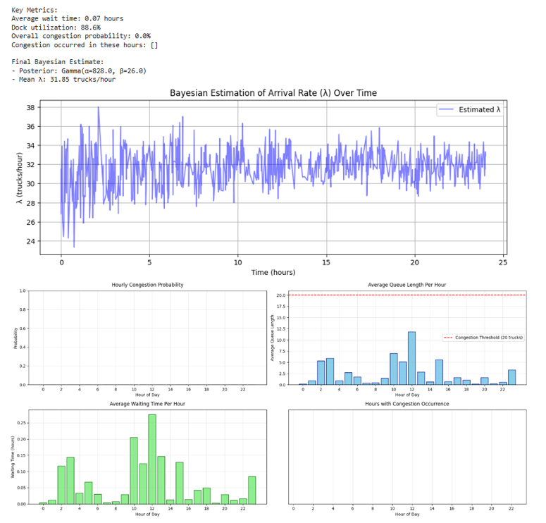

**Figure 3.** System Performance under scenario III

Figure 3 demonstrates the system performance under Scenario III. The slight expansion in number of docks yields a substantial improvement in overall system efficiency. Despite maintaining the same truck arrival rate as in Scenario II at 31.85 (~32) trucks/hour, the average wait time drops sharply to just 0.07 hours (~ 4 minutes 12 seconds). This situation indicates rucks are now serviced almost immediately upon arrival. Dock utilization remains high at 88.6%, but it has decreased the near-saturation level observed in Scenario II, reflecting a more balanced workload. Most critically, congestion is entirely eliminated, where no instances were recorded over the 24-hour period. This improvement is supported by hourly queue length and waiting time plots, which remain consistently low, even during previously congested peak hours. Compared to scenario II, the system under scenario III handles traffic with greater resilience and responsiveness. These findings demonstrate how even modest infrastructure upgrades can dramatically improve performance and reduce bottlenecks in high-demand logistics settings.

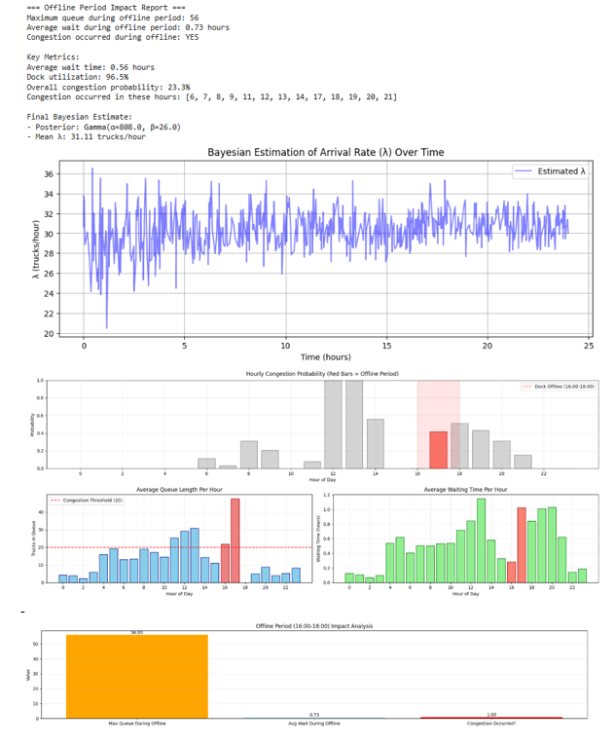

**Figure 4.** Simulation results under scenario IV

Now, in the last scenario, we will consider an event where a dock is taken offline for 2 hours. Assume that during this period, there is a shift change for employees and the dock requires a scheduled rest. Figure 4 illustrates the system’s performance under this scenario (scenario IV), where the dock is unavailable between 16:00 and 18:00. This temporary reduction in service capacity significantly impacts system efficiency. The average waiting time rises to 0.56 hours (~ 34 minutes), while dock utilization reaches 96.5%, indicating that the remaining docks are operating under high stress. More critically, during the offline period, the average waiting time spike to 0.73 hours (45 minutes), and the maximum queue length peaks at 56 trucks, creating a bottleneck that cascades across operations.

Notably, congestion probability jumps to 23.3%, with congestion occurring not only during the offline window but also in the hours preceding and following it, particularly between 6:00–14:00 and 17:00–21:00. Bayesian estimation confirms stable arrival rates at 31.11 (~31) trucks/hour, reinforcing that the congestion is not due to increased demand but rather the temporary loss of server/docks.

A comparative analysis across the four simulated scenarios highlights a consistent and critical pattern, that is congestion is far more sensitive to disruptions in dock availability than to fluctuations in truck arrivals. In Scenario II, high arrival rates (~ 32 trucks/hour) with only 3 docks, the system experienced severe congestion. By contrast, adding just one dock in scenario III while maintaining identical truck flow reduces average waiting time from 40 minutes to under 5 minutes and eliminates congestion entirely.

This pattern becomes even more pronounced during operational disruptions. Scenario IV shows a temporary two-hour reduction in dock availability causes a significant spike in congestion probability and triggers queue lengths of 56 trucks. These findings underscore that short-term reductions in service infrastructure can introduce disproportionate strain on the system, especially during peak operational hours. The results strongly suggest that proactive capacity management, through both infrastructure investment and careful operational scheduling, represents the most effective strategy for maintaining efficient truck flow and minimizing congestion risk in port logistics.

**5. Discussion**

Across the four simulated scenarios, we examine the dynamics of truck flow and congestion risk in a port logistics setting under varying operational conditions. Scenario I reveals a balanced system with manageable queue lengths and minimal delays under normal condition. When truck arrival rates increase in scenario II, the system becomes strained, leading to longer wait times and higher congestion risk. This stress is effectively mitigated in Scenario III through a single additional dock, which reduces average wait times to just 0.07 hours (~ 4 minutes 12 seconds) while handling the same arrival rate as Scenario II, highlighting how targeted server/docks expansion can optimize flow.

Scenario IV examines a critical vulnerability, scheduled downtime due to employee shift changes and maintenance. Although truck arrival rates remain stable, the temporary loss of one dock introduces a significant bottleneck. The average queue length spikes to 56 trucks, waiting times increase markedly, and congestion risk rises to 23.3%. Crucially, these effects persist beyond the offline window, demonstrating how temporary capacity reductions can create lasting bottlenecks. The Bayesian model confirms that congestion tends to arise from reduced service availability rather than a surge in truck arrivals.

The simulation framework provides a powerful way to understand how small operational disruptions can create large-scale inefficiencies in truck logistics. By capturing temporal patterns in congestion and queue formation, it allows decision-makers to pinpoint vulnerable time windows and pre-emptively allocate resources to minimize delays. For instance, identifying peak congestion hours allows for dynamic rescheduling of non-critical operations or shift transitions to reduce service interruptions.

Moreover, the integration of Bayesian estimation strengthens the framework’s predictive capability by continuously updating truck arrival rate estimates based on observed data. This allows port authorities can evaluate different operational strategies to identify the most effective approaches for reducing delays and improving system reliability. In doing so, the model serves as a decision support tool, not only for analyzing current performance but also for testing "what-if" scenarios that inform strategic planning and resilience-building across port operations.

**6. Conclusion**

This study highlights that effective truck flow management and minimizing congestion risk require both long-term capacity planning and robust short-term operational strategies. While expanding dock capacity effectively addresses growing truck flow, the study reveals how even temporary disruptions, like scheduled shift changes can create severe bottlenecks with cascading delays. The integration of simulation modelling with Bayesian analytics offers port operators a sophisticated toolkit to anticipate vulnerabilities, evaluate mitigation strategies, and make evidence-based decisions.

The findings particularly emphasize the value of scenario testing during planning phases. Through simulated stress testing of various operational configurations, ports can identify optimal strategies for maintaining truck flow movement while minimizing costly downtime. This proactive planning not only enhances operational resilience but also strengthens overall supply chain efficiency and economic competitiveness.

References

[1] T. E. Notteboom and H. E. Haralambides, “Port management and governance in a post-COVID-19 era: quo vadis?,” 2020. doi: 10.1057/s41278-020-00162-7.

[2] M. Ma, X. Li, H. Fan, L. Qin, and L. Wei, “Actual Truck Arrival Prediction at a Container Terminal with the Truck Appointment System Based on the Long Short-Term Memory and Transformer Model,” *J Mar Sci Eng*, vol. 13, no. 3, Mar. 2025, doi: 10.3390/jmse13030405.

[3] L. N. Hakim, “Pengusaha Truk Rugi Rp120 Miliar Imbas Macet Parah Tanjung Priok,” https://ekonomi.bisnis.com/read/20250418/98/1870149/pengusaha-truk-rugi-rp120-miliar-imbas-macet-parah-tanjung-priok.

[4] L. Vukić and K. Lai, “Acute port congestion and emissions exceedances as an impact of COVID-19 outcome: the case of San Pedro Bay ports,” *Journal of Shipping and Trade*, vol. 7, no. 1, 2022, doi: 10.1186/s41072-022-00126-5.

[5] A. Carranza, “LA, Long Beach port congestion could disrupt $90B in trade: Russell,” https://www.supplychaindive.com/news/port-congestion-holiday-season-russell-analysis/606186/?

[6] W. Seaburg, “What if we eliminated all idling?,” https://www.fleetowner.com/perspectives/ideaxchange/blog/55289600/eliminating-truck-idling-unlocking-environmental-economic-and-health-benefits-for-a-greener-future.

[7] C. Zhang, M. Juraschek, and C. Herrmann, “Deep reinforcement learning-based dynamic scheduling for resilient and sustainable manufacturing: A systematic review,” Dec. 01, 2024, *Elsevier B.V.* doi: 10.1016/j.jmsy.2024.10.026.

[8] C. Pedroza *et al.*, “Advantages of Bayesian monitoring methods in deciding whether and when to stop a clinical trial: An example of a neonatal cooling trial,” *Trials*, vol. 17, no. 1, 2016, doi: 10.1186/s13063-016-1480-4.

[9] S. Greenland, “Bayesian perspectives for epidemiological research. II. Regression analysis,” *Int J Epidemiol*, vol. 36, no. 1, 2007, doi: 10.1093/ije/dyl289.

[10] H. Braham, L. Berdjoudj, M. Boualem, and N. Rahmania, “Analysis of a non-Markovian queueing model: Bayesian statistics and MCMC methods,” *Monte Carlo Methods Appl*, vol. 25, no. 2, 2019, doi: 10.1515/mcma-2019-2035.

[11] D. Gross, J. F. Shortie, J. M. Thompson, and C. M. Harris, *Fundamentals of Queueing Theory: Fourth Edition*. 2013. doi: 10.1002/9781118625651.

[12] B. D’Auria, I. J. B. F. Adan, R. Bekker, and V. Kulkarni, “An M/M/c queue with queueing-time dependent service rates,” *Eur J Oper Res*, vol. 299, no. 2, 2022, doi: 10.1016/j.ejor.2021.12.023.

[13] R. S. Kenett, D. Gross, and C. M. Harris, “Fundamentals of Queueing Theory.,” *The Statistician*, vol. 35, no. 5, 1986, doi: 10.2307/2987982.

[14] M. Harchol-Balter, *Performance modeling and design of computer systems: Queueing theory in action*, vol. 9781107027503. 2010. doi: 10.1017/CBO9781139226424.

[15] M. K. Pasupuleti, “Stochastic Computation for AI: Bayesian Inference, Uncertainty, and Optimization,” Delhi, Mar. 2025. doi: 10.62311/nesx/rriv325.

[16] H. Ohno, “Quantum inference for Bayesian networks: an empirical study,” *Quantum Machine Intelligence* , vol. 7, no. 21, 2025.

[17] D. Matloff, Norm S (University of California, “Introduction to discrete-event simulation and the simpy language,” *Davis, CA. Dept of Computer Science. University*, 2008.

[18] G. Dagkakis, C. Heavey, S. Robin, and J. Perrin, “ManPy: An open-source layer of des manufacturing objects implemented in SimPy,” in *Proceedings - 8th EUROSIM Congress on Modelling and Simulation, EUROSIM 2013*, 2015. doi: 10.1109/EUROSIM.2013.70.